Supplementary Materials
List of supplementary materials
- Supplementary Figure 1. Manhattan plots of p-values of 5,375,073 SNPs obtained by a meta-analysis of two HBV-related HCC GWASs in Chinese populations.
- Supplementary Figure 2. The quantile-quantile plots of p-values of 5,375,073 SNPs obtained by a meta-analysis of two HBV-related HCC GWASs in Chinese populations.
- Supplementary Figure 3. Regulatory annotations at gene RNY4.
- Supplementary Figure 4. Regulatory annotations at gene LINC01207.
- Supplementary Figure 5. Regulatory annotations at gene WHAMMP2.
- Supplementary Figure 6. Visualization of regulatory annotation at rs17343667 by RegulomeDB.
- Supplementary Table 1. Genetic association p-values of genes preferentially expressed in liver.
- Supplementary Table 2. Association p-values of genes frequently intergraded by HBV
- Supplementary Table 3. Association p-values of genes with significant association in previous studies
- Supplementary Table 4. Association p-values of COSMIC HCC risk genes.
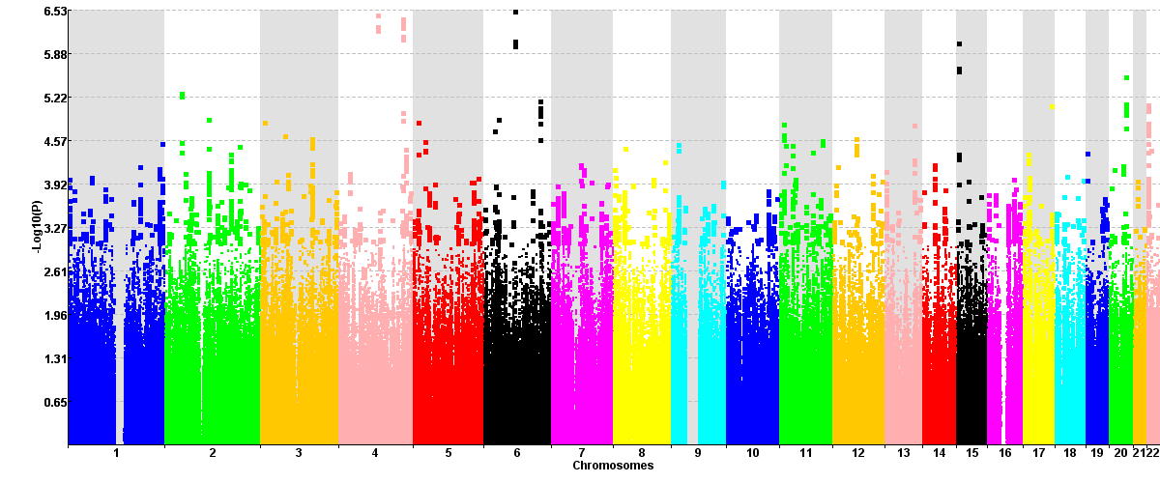
Supplementary Figure 1. Manhattan plots of p-values of 5,375,073 SNPs obtained by a meta-analysis of two HBV-related HCC GWASs in Chinese populations. The p-values are taken –log10 to visualize significance of small p-values.

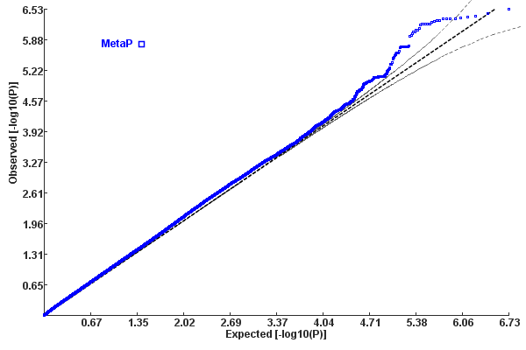
Supplementary Figure 2. The quantile-quantile plots of p-values of 5,375,073 SNPs obtained by a meta-analysis of two HBV-related HCC GWASs in Chinese populations.

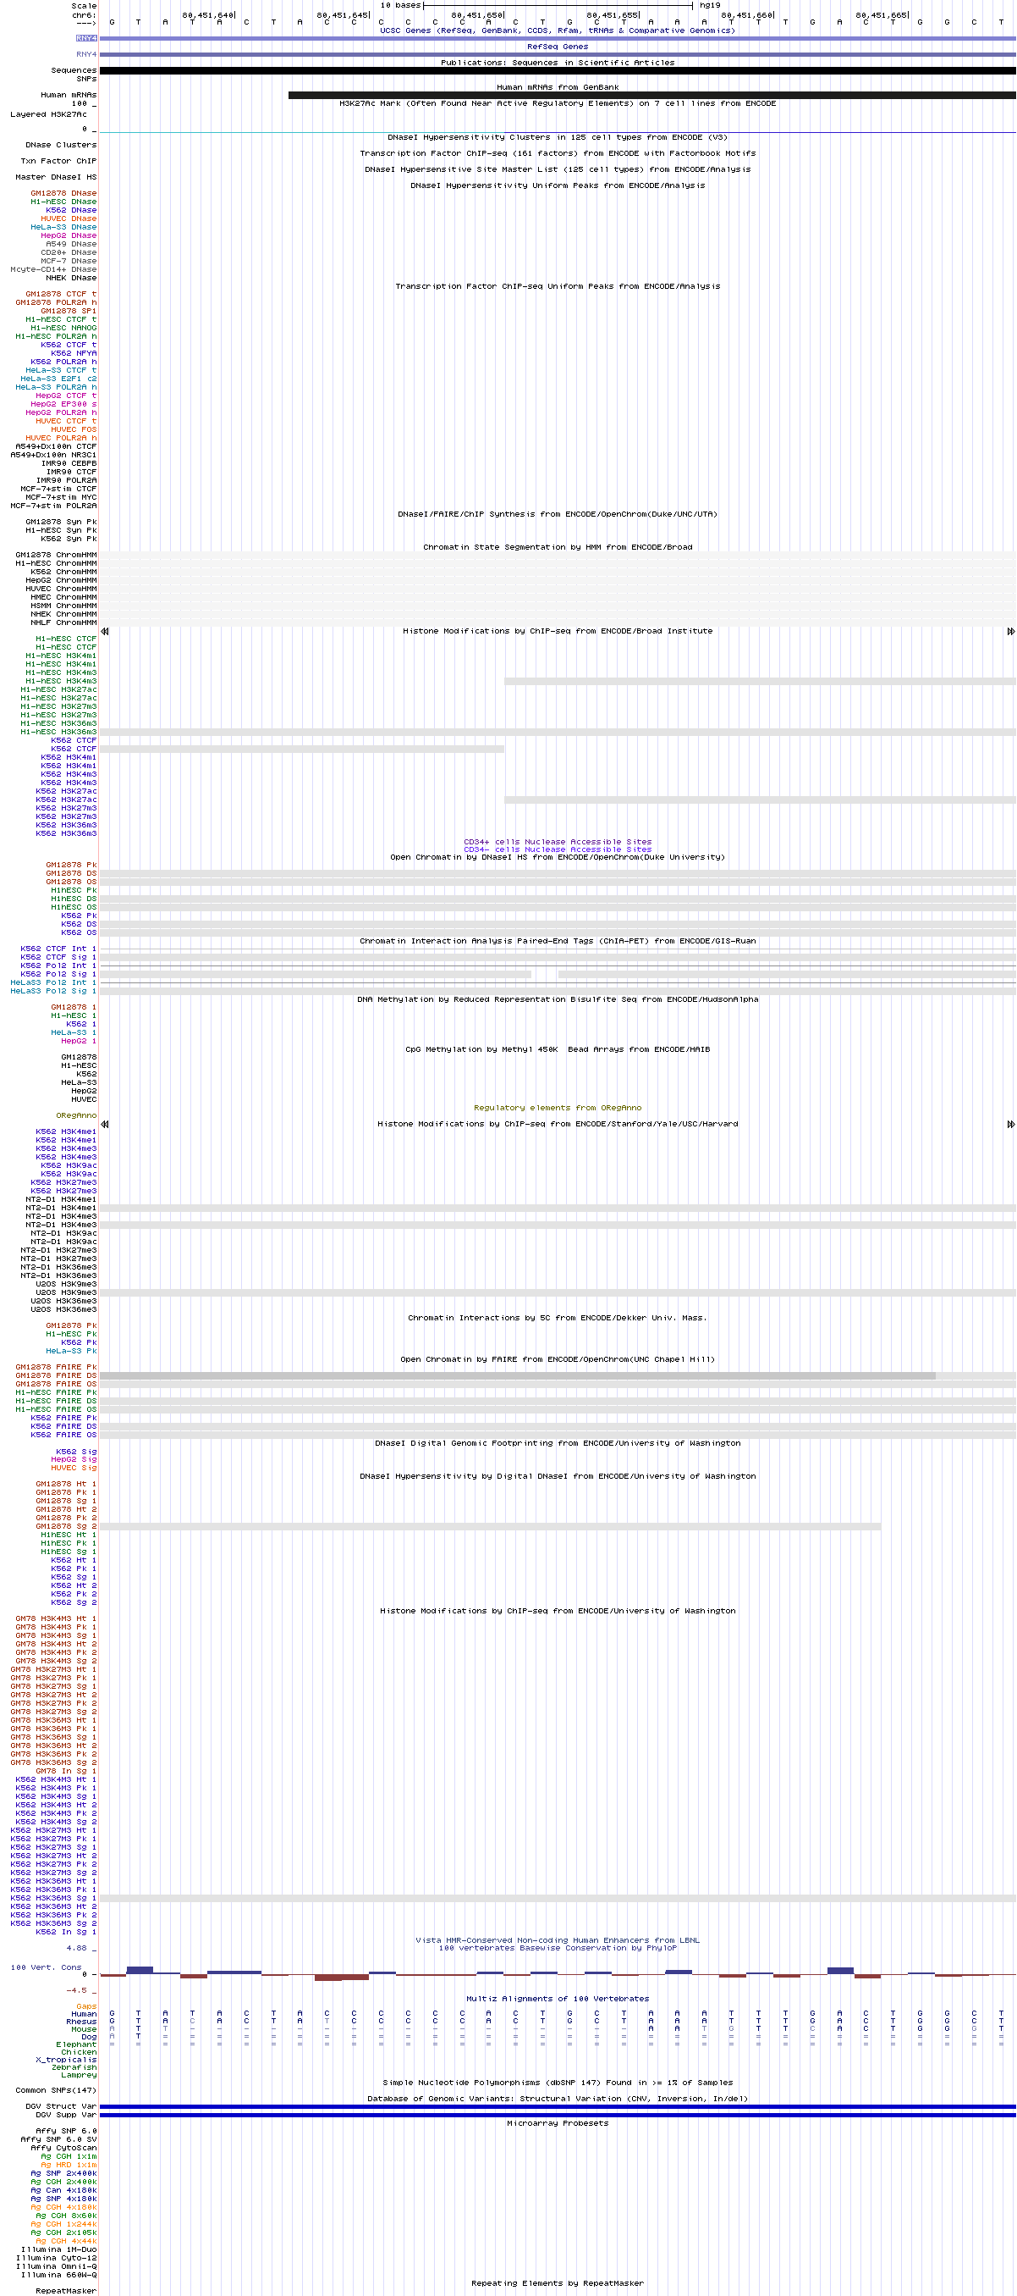
Supplementary Figure 3. Regulatory annotations at gene RNY4. This plot is produced by UCSC genome browser (http://genome.ucsc.edu). The regulatory options (ENCODE Regulation, Chromatin Interactions, DNA Methylation, Histone Modification, Transcription Factor Binding Tracks, Regulatory elements from ORegAnno, CD34 DnaseI, and Vista Enhancers) were turned on.

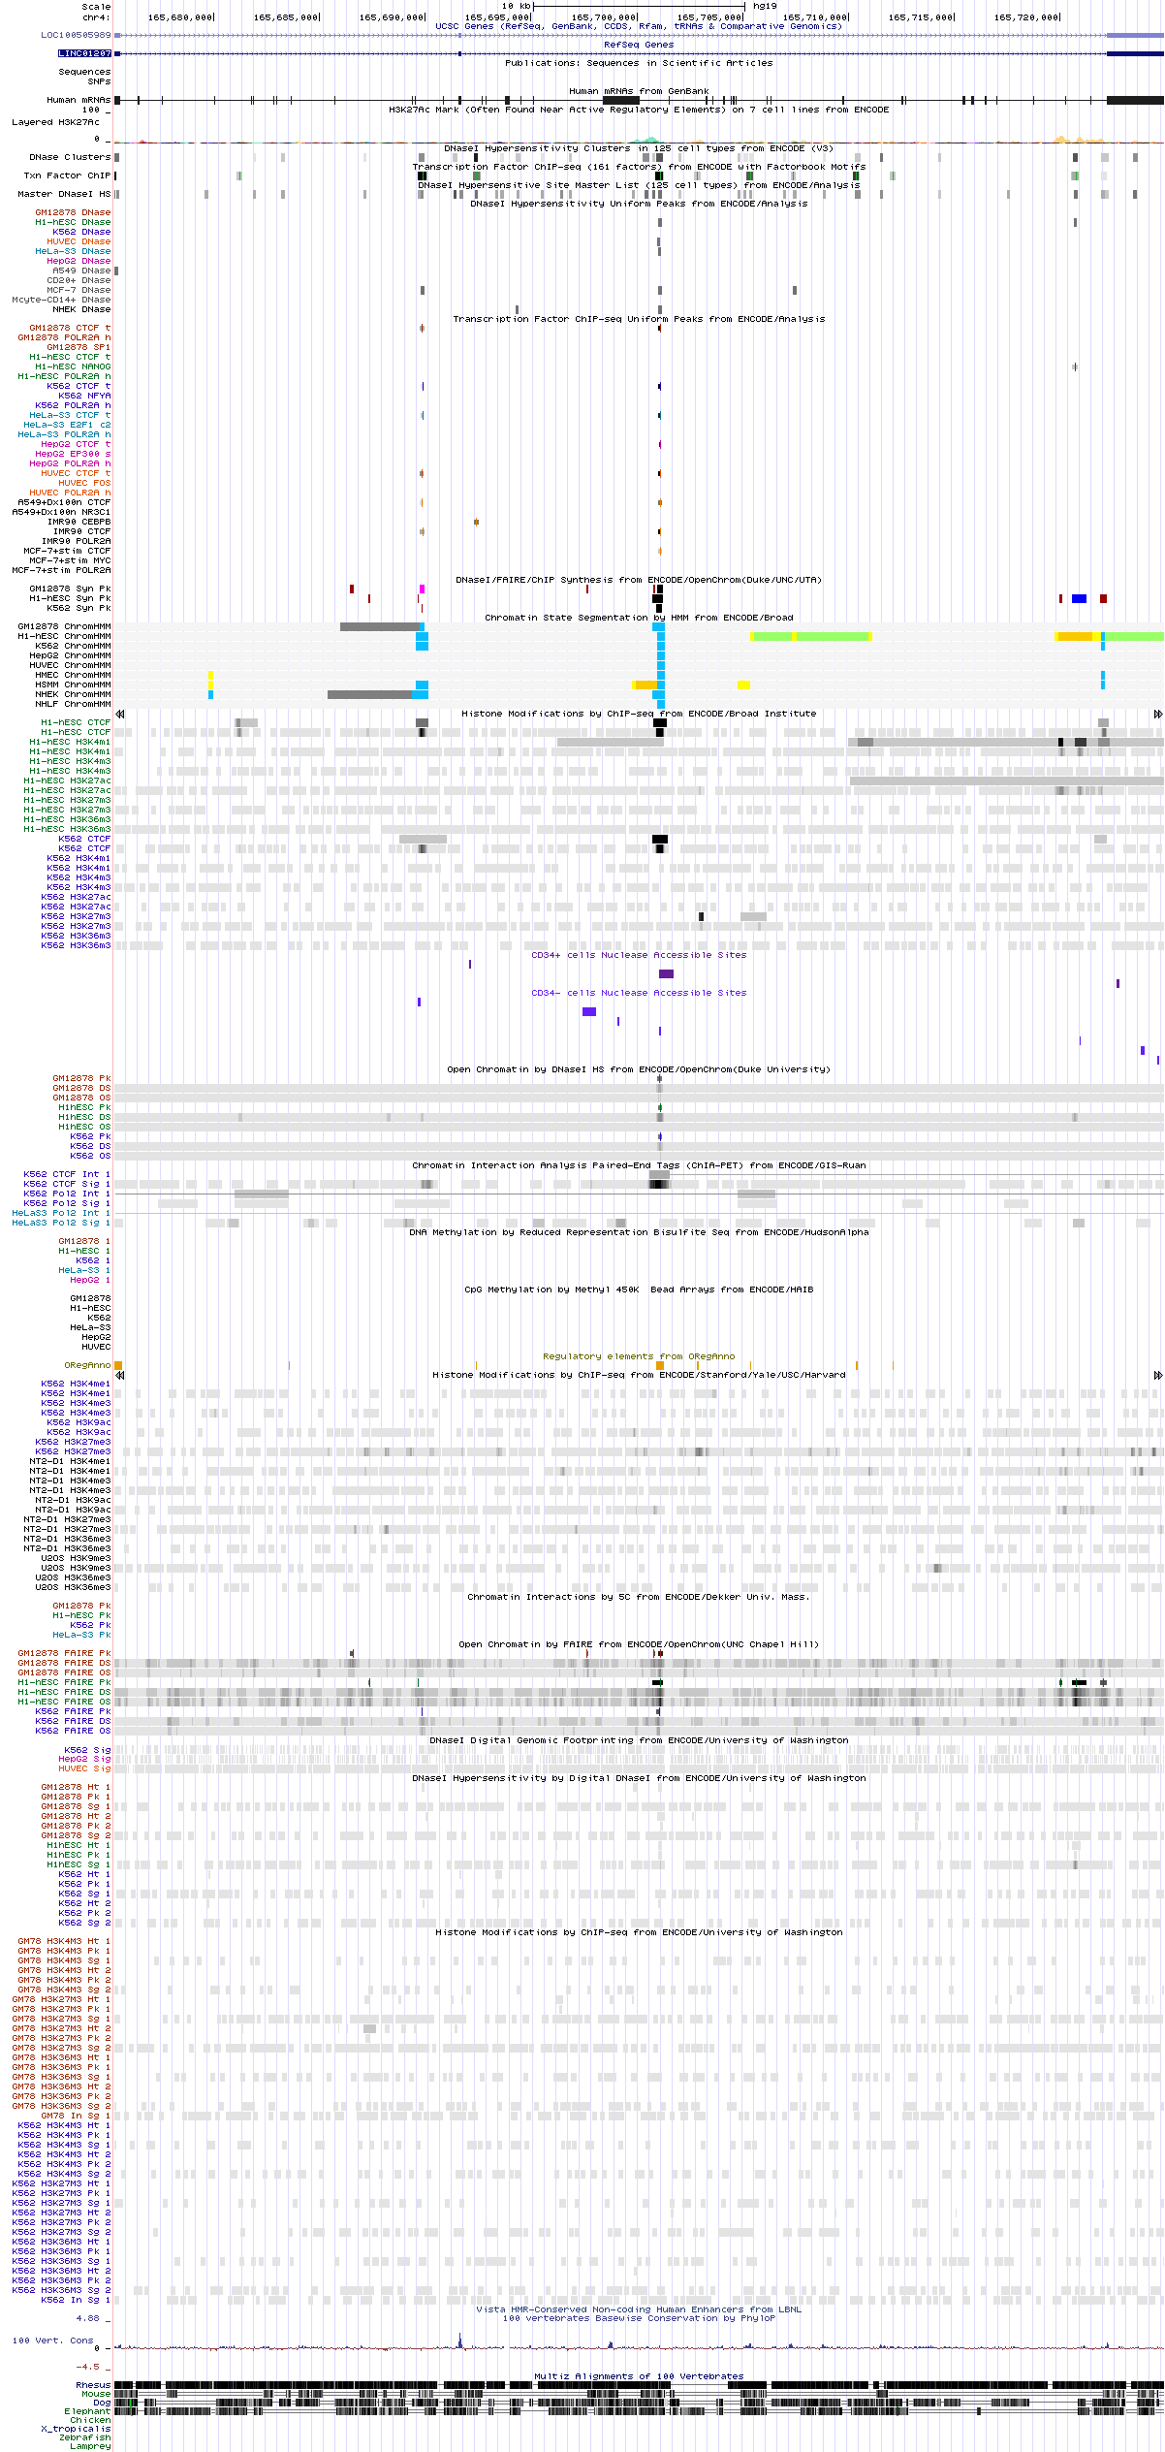
Supplementary Figure 4. Regulatory annotations at gene LINC01207. This plot is produced by UCSC genome browser (http://genome.ucsc.edu). The regulatory options (ENCODE Regulation, Chromatin Interactions, DNA Methylation, Histone Modification, Transcription Factor Binding Tracks, Regulatory elements from ORegAnno, CD34 DnaseI, and Vista Enhancers) were turned on.

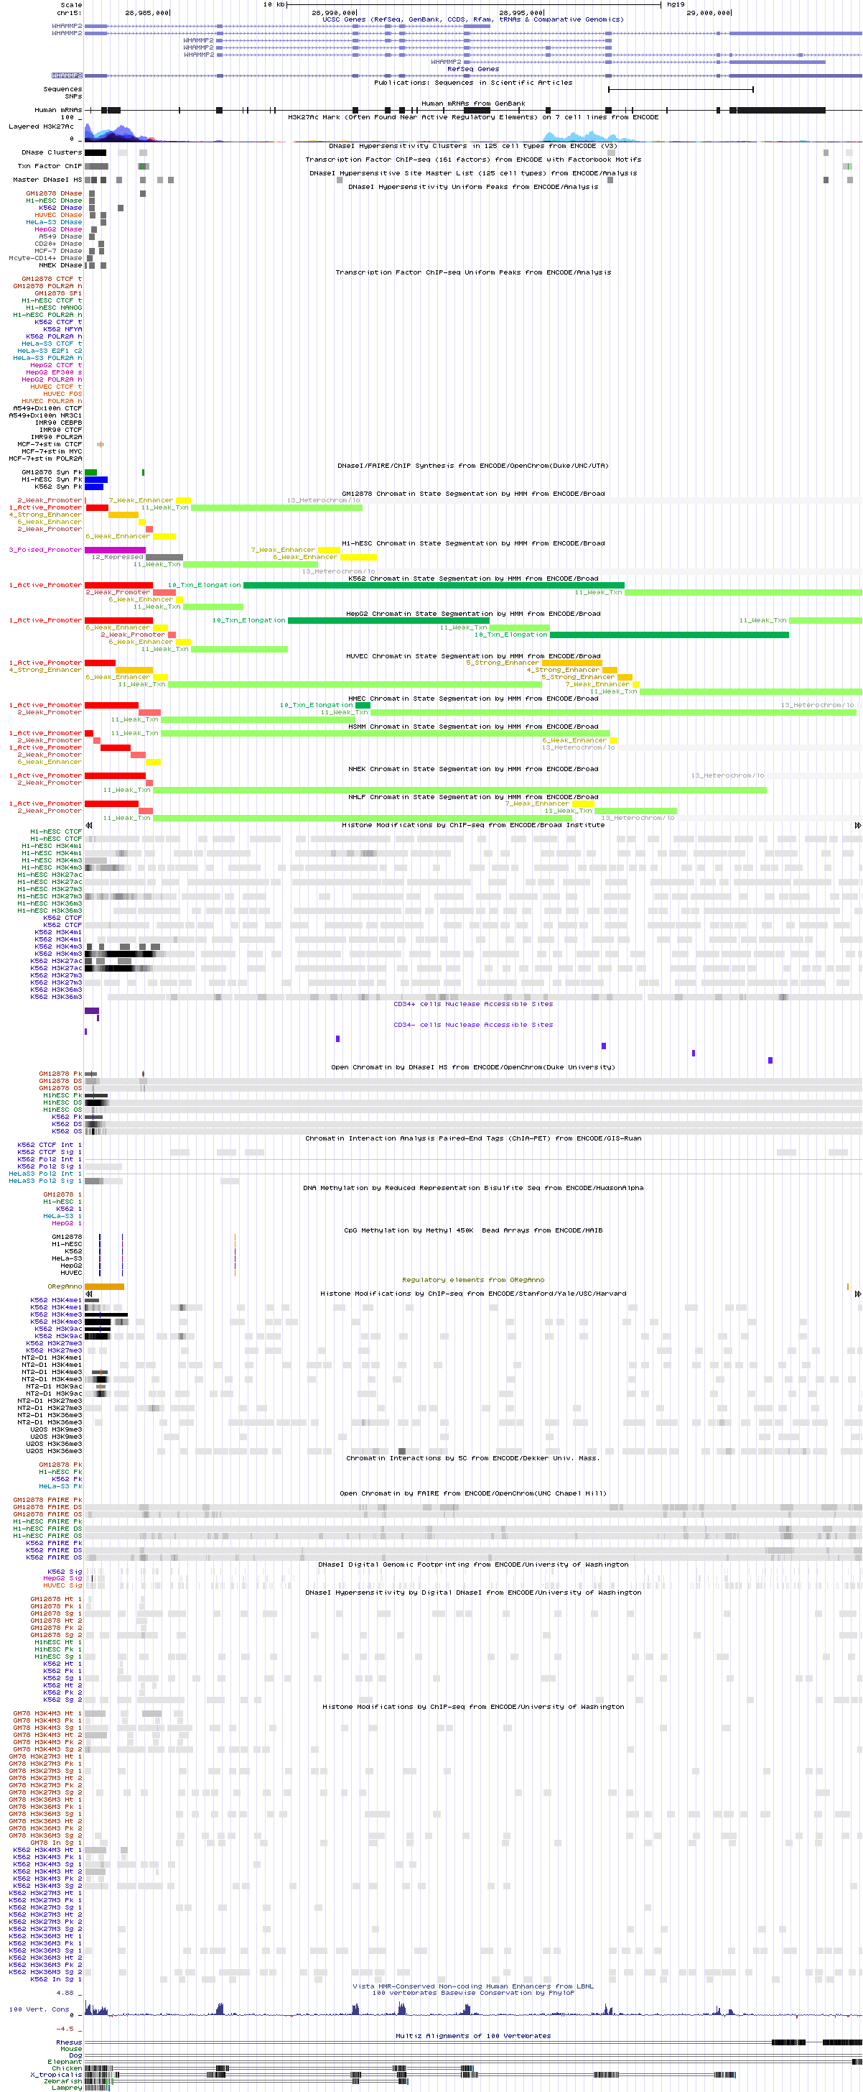
Supplementary Figure 5. Regulatory annotations at gene WHAMMP2. This plot is produced by UCSC genome browser (http://genome.ucsc.edu). The regulatory options (ENCODE Regulation, Chromatin Interactions, DNA Methylation, Histone Modification, Transcription Factor Binding Tracks, Regulatory elements from ORegAnno, CD34 DnaseI, and Vista Enhancers) were turned on.

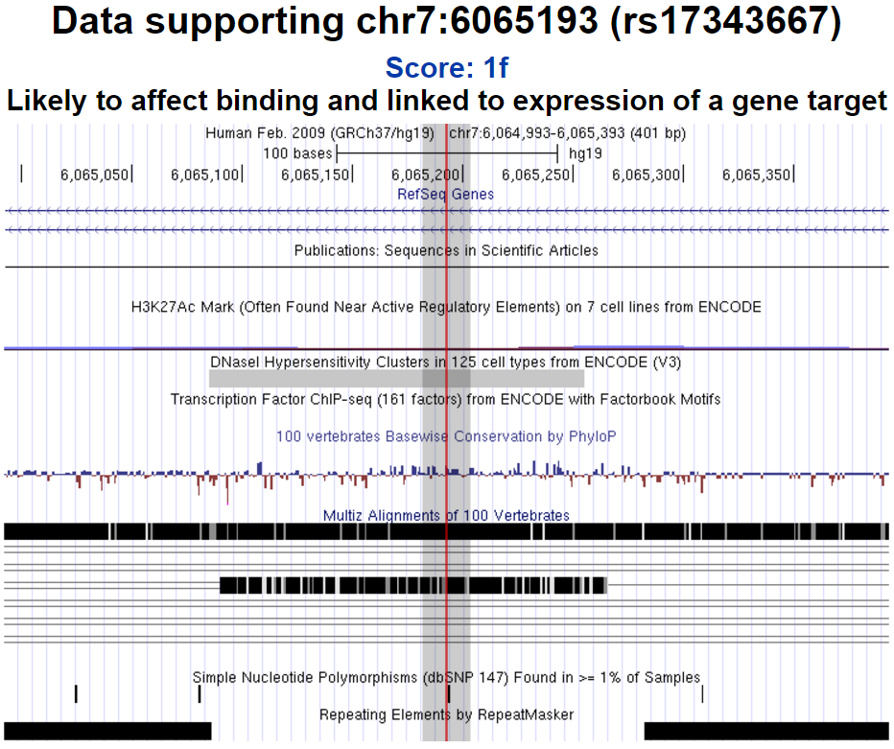
Supplementary Figure 6. Visualization of regulatory annotation at rs17343667 by RegulomeDB. This plot is produced by RegulomeDB (http://www.regulomedb.org) with RS ID.

Supplementary Table 1. Genetic association p-values of genes preferentially expressed in liver
Gene Symbol | p | CHR | Start Position | Length (BP) | Number of SNPs
NAT2 | 0.010 | 8 | 18248754 | 9970 | 69
GSTA1 | 0.011 | 6 | 52656177 | 12589 | 50
GSTA2 | 0.013 | 6 | 52614884 | 13478 | 36
UGT2B10 | 0.017 | 4 | 69870294 | -172558 | 116
UROC1 | 0.027 | 3 | 126200007 | 36610 | 89
AQP9 | 0.032 | 15 | 58430394 | 47714 | 182
HAO1 | 0.033 | 20 | 7863630 | 57464 | 117
TF | 0.036 | 3 | 133464976 | 32875 | 93
SAA2 | 0.037 | 11 | 18266774 | 3448 | 51
C3 | 0.041 | 19 | 6677845 | 42849 | 138
FGL1 | 0.056 | 8 | 17721899 | 31015 | 197
SLCO1B3 | 0.056 | 12 | 20963637 | 106207 | 528
LBP | 0.058 | 20 | 36974813 | 30841 | 119
C4A | 0.061 | 6 | 31949833 | 20625 | 19
FGG | 0.072 | 4 | 155525727 | 8176 | 18
RBP4 | 0.073 | 10 | 95351592 | 9402 | 42
ASGR1 | 0.074 | 17 | 7076750 | 6134 | 6
HPR | 0.080 | 16 | 72097124 | 14022 | 27
TAT | 0.083 | 16 | 71600753 | 10246 | 24
AGXT2 | 0.096 | 5 | 34998205 | 50036 | 211
APOA2 | 0.101 | 1 | 161192082 | 1337 | 21
LRG1 | 0.106 | 19 | 4537226 | 2811 | 6
HP | 0.114 | 16 | 72088490 | 6466 | 20
HSD17B6 | 0.117 | 12 | 57157001 | 24574 | 40
C4B | 0.119 | 6 | 31982571 | -12112 | 36
ALDH8A1 | 0.124 | 6 | 135238527 | 32734 | 65
CPB2 | 0.125 | 13 | 46627321 | 51891 | 154
SERPINC1 | 0.126 | 1 | 173872941 | 13576 | 35
RIDA | 0.132 | 8 | 99114566 | 14853 | 54
SLCO1B1 | 0.133 | 12 | 21284127 | 108604 | 293
CYP2A7 | 0.140 | 19 | 41381343 | 7315 | 83
CYP3A7 | 0.142 | 7 | 99302659 | 30165 | 56
ORM1 | 0.142 | 9 | 117085302 | 3458 | 40
FGA | 0.147 | 4 | 155506411 | 5508 | 21
C4BPB | 0.152 | 1 | 207262627 | 10711 | 29
PON3 | 0.158 | 7 | 94989183 | 36505 | 54
HRG | 0.160 | 3 | 186383740 | 12290 | 58
APOH | 0.164 | 17 | 64208146 | 17411 | 73
CYP4F2 | 0.169 | 19 | 15988833 | 20098 | 101
INHBC | 0.181 | 12 | 57828467 | 17379 | 36
F2 | 0.188 | 11 | 46740715 | 20344 | 28
AMBP | 0.195 | 9 | 116822407 | 18346 | 77
SERPINA4 | 0.200 | 14 | 95027756 | 8495 | 53
C5 | 0.219 | 9 | 123761956 | 50596 | 149
C4BPA | 0.223 | 1 | 207277606 | 40712 | 69
AFP | 0.241 | 4 | 74301935 | 19568 | 32
EHHADH | 0.264 | 3 | 184908411 | 63476 | 109
FGB | 0.265 | 4 | 155484131 | 9785 | 40
CYP7A1 | 0.265 | 8 | 59402736 | 9985 | 41
ABCC2 | 0.265 | 10 | 101542354 | 69596 | 91
ALDOB | 0.270 | 9 | 104182841 | 15222 | 33
FMO5 | 0.280 | 1 | 146657839 | 39392 | 95
SERPINA3 | 0.282 | 14 | 95078713 | 11678 | 37
SULT2A1 | 0.285 | 19 | 48373722 | 15933 | 55
TDO2 | 0.286 | 4 | 156824844 | 16715 | 54
APOM | 0.286 | 6 | 31623670 | 2318 | 28
FMO3 | 0.286 | 1 | 171060017 | 26943 | 108
TM4SF4 | 0.293 | 3 | 149192367 | 28815 | 176
ANG | 0.298 | 14 | 21156931 | 5415 | 39
ASGR2 | 0.304 | 17 | 7004640 | 12990 | 111
FABP1 | 0.306 | 2 | 88422507 | 5144 | 26
ADH1C | 0.308 | 4 | 100257648 | 16555 | 107
C8B | 0.312 | 1 | 57394882 | 36932 | 97
SERPINA1 | 0.315 | 14 | 94843083 | 12071 | 50
FETUB | 0.320 | 3 | 186358148 | 12650 | 45
GATM | 0.323 | 15 | 45653321 | 17660 | 60
PAH | 0.339 | 12 | 103232103 | 79279 | 203
SLC22A7 | 0.351 | 6 | 43265997 | 7280 | 12
ALB | 0.363 | 4 | 74269971 | 17159 | 40
CXCL2 | 0.368 | 4 | 74962753 | 2245 | 10
TFR2 | 0.374 | 7 | 100218038 | 13236 | 39
HAO2 | 0.382 | 1 | 119911398 | 25356 | 60
HGD | 0.384 | 3 | 120347014 | 54405 | 37
PON1 | 0.384 | 7 | 94927668 | 26217 | 86
SLC25A18 | 0.393 | 22 | 18043138 | 30519 | 65
SPP2 | 0.395 | 2 | 234959345 | 26432 | 123
ITIH4 | 0.396 | 3 | 52847005 | 17713 | 37
NR1H4 | 0.408 | 12 | 100897137 | 60509 | 145
C8A | 0.412 | 1 | 57320442 | 63453 | 194
HNF4A | 0.425 | 20 | 43029895 | 23382 | 169
PIPOX | 0.425 | 17 | 27369917 | 14320 | 21
HABP2 | 0.425 | 10 | 115312736 | 36625 | 165
KHK | 0.426 | 2 | 27309610 | 14010 | 18
AADAC | 0.429 | 3 | 151531860 | 14417 | 101
F12 | 0.437 | 5 | 176829138 | 7440 | 9
AKR1D1 | 0.447 | 7 | 137761177 | 41874 | 113
APOA1 | 0.447 | 11 | 116706466 | 1837 | 46
LIPC | 0.450 | 15 | 58724174 | 136900 | 387
AGTR1 | 0.455 | 3 | 148447966 | 12825 | 107
VTN | 0.457 | 17 | 26694298 | 3076 | 15
DIO1 | 0.459 | 1 | 54359860 | 16900 | 86
ITIH3 | 0.465 | 3 | 52828783 | 14243 | 25
RDH16 | 0.498 | 12 | 57345214 | 7945 | 29
SAA1 | 0.504 | 11 | 18287771 | 3753 | 37
CYP2B6 | 0.515 | 19 | 41497203 | 27099 | 98
PZP | 0.516 | 12 | 9301435 | 59532 | 121
DPYS | 0.521 | 8 | 105391651 | 87627 | 152
SERPINA5 | 0.525 | 14 | 95047705 | 11753 | 112
CYP2J2 | 0.529 | 1 | 60358979 | 33492 | 45
NR0B2 | 0.533 | 1 | 27237974 | 2594 | 1
AOX1 | 0.544 | 2 | 201450730 | 85488 | 208
HFE2 | 0.567 | 1 | 145413190 | 4356 | 10
HPN | 0.575 | 19 | 35531409 | 26069 | 73
NR1I3 | 0.580 | 1 | 161199455 | 8546 | 36
GC | 0.594 | 4 | 72607410 | 42670 | 143
ADRA1A | 0.599 | 8 | 26627221 | 95702 | 335
GYS2 | 0.600 | 12 | 21689122 | 68660 | 164
HMGCS2 | 0.603 | 1 | 120290618 | 20938 | 45
SERPINA10 | 0.605 | 14 | 94749649 | 9713 | 28
G6PC | 0.618 | 17 | 41052813 | 13638 | 11
CYP2A6 | 0.621 | 19 | 41349442 | 6911 | 28
ARG1 | 0.625 | 6 | 131894343 | 11130 | 19
A1BG | 0.630 | 19 | 58858171 | 6695 | 24
SLC22A1 | 0.634 | 6 | 160542862 | 36889 | 71
HAL | 0.652 | 12 | 96366439 | 23705 | 89
SERPINF2 | 0.660 | 17 | 1646319 | 12241 | 57
MASP2 | 0.664 | 1 | 11104854 | 2443 | 54
BHMT2 | 0.667 | 5 | 78365546 | 20352 | 57
APCS | 0.679 | 1 | 159557615 | 1047 | 16
CPN1 | 0.681 | 10 | 101802064 | 39579 | 88
PROC | 0.684 | 2 | 128175995 | 10828 | 42
CYP3A43 | 0.697 | 7 | 99425635 | 38093 | 12
AZGP1 | 0.704 | 7 | 99564349 | 9387 | 19
AFM | 0.712 | 4 | 74347461 | 22258 | 35
UPB1 | 0.714 | 22 | 24891250 | 31304 | 58
ITIH1 | 0.715 | 3 | 52813941 | 12144 | 37
LECT2 | 0.717 | 5 | 135282599 | 8125 | 62
SERPIND1 | 0.727 | 22 | 21128382 | 13627 | 51
CYP2C8 | 0.731 | 10 | 96796528 | 32727 | 109
C9 | 0.738 | 5 | 39284377 | 80279 | 202
PROZ | 0.746 | 13 | 113812967 | 13732 | 63
CYP3A4 | 0.752 | 7 | 99354582 | 27230 | 16
SLC13A5 | 0.765 | 17 | 6588031 | 28710 | 97
AGT | 0.765 | 1 | 230838271 | 12066 | 86
ITIH2 | 0.767 | 10 | 7745235 | 46249 | 114
GNMT | 0.767 | 6 | 42928491 | 3128 | 27
PKLR | 0.768 | 1 | 155259083 | 11710 | 27
SLC27A5 | 0.782 | 19 | 59009699 | 13734 | 40
HPD | 0.788 | 12 | 122277432 | 19338 | 105
APOC3 | 0.790 | 11 | 116700623 | 3165 | 60
ADH6 | 0.796 | 4 | 100125878 | 14526 | 27
PLG | 0.806 | 6 | 161123224 | 9681 | 61
AGXT | 0.809 | 2 | 241808161 | 10376 | 100
HPX | 0.814 | 11 | 6452267 | 9988 | 30
CRP | 0.818 | 1 | 159682078 | 2302 | 21
COLEC10 | 0.818 | 8 | 120079423 | 39780 | 124
ANGPTL3 | 0.827 | 1 | 63063157 | 8820 | 12
KNG1 | 0.832 | 3 | 186435097 | 25582 | 177
APOC1 | 0.840 | 19 | 45417920 | 4687 | 29
C8G | 0.844 | 9 | 139839697 | 1730 | 11
ORM2 | 0.849 | 9 | 117092068 | 3469 | 37
SLC38A4 | 0.849 | 12 | 47158543 | 61238 | 178
BHMT | 0.850 | 5 | 78407603 | 20511 | 59
SAA4 | 0.859 | 11 | 18252901 | 5484 | 18
DMGDH | 0.860 | 5 | 78316489 | 49009 | 228
ADH1B | 0.863 | 4 | 100227543 | 15057 | 33
ADH1A | 0.864 | 4 | 100197522 | 14664 | 29
TMPRSS6 | 0.869 | 22 | 37461475 | 38219 | 117
SDS | 0.871 | 12 | 113830250 | 11443 | 25
F13B | 0.875 | 1 | 197008320 | 28078 | 42
AKR1C4 | 0.875 | 10 | 5238797 | 22114 | 125
APOB | 0.879 | 2 | 21224300 | 42646 | 43
APOC2 | 0.880 | 19 | 45449238 | 3585 | 61
F11 | 0.886 | 4 | 187187117 | 23719 | 65
SLC2A2 | 0.888 | 3 | 170714136 | 30633 | 19
UGT2B4 | 0.888 | 4 | 70345882 | 15745 | 192
CYP2C18 | 0.896 | 10 | 96443250 | 52698 | 152
CYP2E1 | 0.899 | 10 | 135340866 | 11755 | 83
CYP2D6 | 0.908 | 22 | 42522500 | 4384 | 37
ADH4 | 0.910 | 4 | 100044807 | 20643 | 27
SLC10A1 | 0.916 | 14 | 70242551 | 21456 | 33
MAT1A | 0.919 | 10 | 82031575 | 17860 | 19
ABAT | 0.924 | 16 | 8814572 | 63861 | 385
CYP2C9 | 0.925 | 10 | 96698414 | 50735 | 75
C6 | 0.926 | 5 | 41142247 | 71449 | 238
BAAT | 0.931 | 9 | 104122698 | 23104 | 33
PCSK6 | 0.955 | 15 | 101923952 | 106236 | 730
NR1I2 | 0.958 | 3 | 119501556 | 35777 | 71
CPS1 | 0.963 | 2 | 211458078 | 85754 | 377
APOC4 | 0.978 | 19 | 45445494 | 3260 | 42
OIT3 | 0.980 | 10 | 74653313 | 39482 | 30
GLYAT | 0.982 | 11 | 58477560 | 21888 | 76
AHSG | 0.984 | 3 | 186330849 | 8259 | 39
KLKB1 | 0.996 | 4 | 187148624 | 31005 | 142
SERPINA6 | 0.998 | 14 | 94770584 | 19105 | 65
Note. CHR: chromosome; BP: base pairs.

Supplementary Table 2. Association p-values of genes frequently intergraded by HBV
Gene Symbol | p | CHR | Start Position | Length (BP) | Number of SNPs
ITPR1 | 0.104 | 3 | 4535031 | 354494 | 729
ESRRG | 0.113 | 1 | 216676587 | 220228 | 1532
TERT | 0.117 | 5 | 1253286 | 41877 | 30
ITPR2 | 0.152 | 12 | 26488269 | 497863 | 933
SENP5 | 0.180 | 3 | 196594726 | 66859 | 117
NTRK2 | 0.262 | 9 | 87285291 | 145333 | 664
MCM8 | 0.422 | 20 | 5931297 | 44556 | 98
IRAK2 | 0.463 | 3 | 10206562 | 78866 | 178
LRP1B | 0.544 | 2 | 140988995 | 1900276 | 4572
PLXNA4 | 0.610 | 7 | 132169520 | 91804 | 807
PHACTR4 | 0.631 | 1 | 28764660 | 62222 | 226
MYOM1 | 0.631 | 18 | 3066804 | 153303 | 344
MAPK1 | 0.642 | 22 | 22123318 | 98653 | 172
ROCK1 | 0.643 | 18 | 18529702 | 162111 | 77
CTDSPL2 | 0.657 | 15 | 44719578 | 99852 | 162
ARHGEF12 | 0.697 | 11 | 120256002 | 104644 | 164
FN1 | 0.714 | 2 | 216279383 | 21409 | 64
CYP2C8 | 0.731 | 10 | 96796528 | 32727 | 109
SMAD5 | 0.744 | 5 | 135468533 | 49890 | 114
RAI1 | 0.818 | 17 | 17584786 | 129980 | 104
CCNE1 | 0.845 | 19 | 30302900 | 12316 | 58
ADH1B | 0.863 | 4 | 100227543 | 15057 | 33
THRAP3 | 0.918 | 1 | 36690016 | 80942 | 26
CPS1 | 0.963 | 2 | 211458078 | 85754 | 377
RBFOX1 | 0.998 | 16 | 7382750 | 377034 | 7391
LRFN2 | 0.999 | 6 | 40359372 | 195832 | 566
Note. CHR: chromosome; BP: base pairs.
Supplementary Table 3. Association p-values of genes with significant association in previous studies
Gene Symbol | p | CHR | Start Position | Length (BP) | Number of SNPs
EFCAB11 | 0.339 | 14 | 90389620 | 31282 | 275
HLA-DQB1 | 0.172 | 6 | 32627240 | 7227 | 53
GRIK1 | 0.118 | 21 | 30971114 | 341169 | 840
GRIN2A | 0.326 | 16 | 9847261 | 428664 | 1001
HLA-DPA1 | 0.566 | 6 | 33032345 | 9110 | 383
HLA-DPB1 | 0.417 | 6 | 33043702 | 13772 | 256
C2 | 0.347 | 6 | 31895253 | 7583 | 54
GLB1 | 0.637 | 3 | 33038099 | 100226 | 290
Note. CHR: chromosome; BP: base pairs.

Supplementary Table 4. Association p-values of COSMIC HCC risk genes
Gene Symbol | p | CHR | Start Position | Length (BP) | Number of SNPs
TERT | 0.117 | 5 | 1253286 | 41877 | 30
PTEN | 0.124 | 10 | 89623194 | 108494 | 48
PTPRB | 0.138 | 12 | 70910631 | 92994 | 231
HNF1A | 0.202 | 12 | 121416370 | 23945 | 77
PIK3CA | 0.255 | 3 | 178866310 | 86188 | 110
RB1 | 0.321 | 13 | 48877882 | 178145 | 161
KMT2D | 0.390 | 12 | 49412757 | 36351 | 21
ATM | 0.403 | 11 | 108093558 | 146269 | 139
TP53 | 0.500 | 17 | 7571719 | 7093 | 49
CREBBP | 0.501 | 16 | 3775055 | 155067 | 121
ARID1A | 0.707 | 1 | 27022521 | 86081 | 4
IL6ST | 0.771 | 5 | 55230924 | 59898 | 16
TSC2 | 0.799 | 16 | 2098202 | 40520 | 12
NFE2L2 | 0.823 | 2 | 178095030 | 33830 | 49
ARID2 | 0.869 | 12 | 46123619 | 178201 | 91
CTNNB1 | 0.877 | 3 | 41240941 | 40999 | 40
AXIN1 | 0.936 | 16 | 337439 | 65238 | 189
ATR | 0.947 | 3 | 142168076 | 129593 | 137
KMT2C | 0.995 | 7 | 151832009 | 301082 | 237
CDKN2A | 0.999 | 9 | 21967750 | 7077 | 37
Note. CHR: chromosome; BP: base pairs.

